FIBROBLAST SKIN AND BEAUTY WHOLESALE PRICE LIST

PRODUCT | RETAIL PRICE | WHOLESALE PRICE  (BUYING MORE THAN 1 UNIT)
CLEANSE BOTTLE  (50 ML)  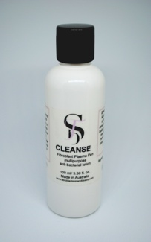  Suitable for all treatments.  To sterilise equipment, device or to clean the client’s skin. | $30.00 per unit (100ml) | $25.00 per unit
HEAL BOTTLE  (50 ML)  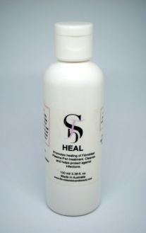  Suitable for all treatments  An antimicrobial pH balancing wound cleaner and fast healing agent. | $30.00 per unit (100ml) | $25.00 per unit
RECOVERY SACHETS  (5 GRAMS)  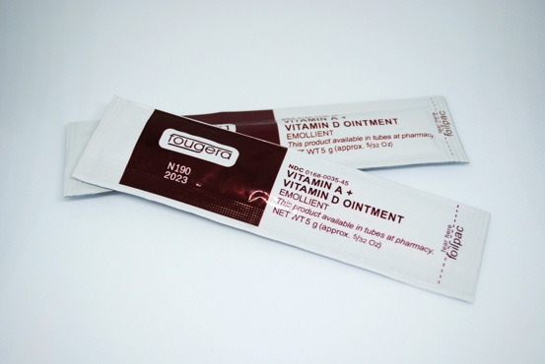  Suitable for all Fibroblast Plasma Pen, Microblading.. For any treatment that creates micro-wounds, cuts or burns. Healing and recovery ointment. | $30.00 per pack of 10 sachets (5g each) | $25.00 per unit
100% HYALURONIC ACID SERUM + ALOE VERA EXTRACT TUB  (50 ML)  Suitable for all treatments  Multi-purpose and beneficial serum | $25.00 per unit (50ml) | $20.00 per unit
100% HYALURONIC ACID SERUM BOTTLE  (100 ML)  Suitable for all treatments  Multi-purpose and beneficial serum | $50.00 per unit (100ml) | $45.00 per unit
BUNDLE PACK  (1x Cleanse Bottle, 1X Heal Bottle, 1X 10-Pack Recovery Sachets & 1X 100% Hyaluronic Acid Serum + Aloe Vera Extract Tub)  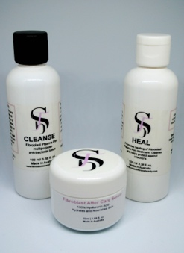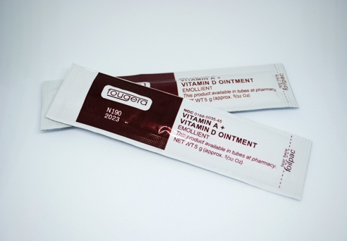  Suitable for all treatments  Refer to each product on the list | $95.00 per pack | $80.00 per pack
PLAMERE PLASMA PEN STRAIGHT THICK COPPER NEEDLES  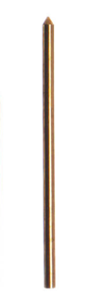  Suitable for Fibroblast Plasma Pen  Thick straight copper needles for Plamere Plasma Pen | Enquire Within | Enquire Within
PLAMERE PLASMA PEN BENDING THICK COPPER NEEDLES  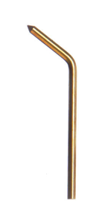  Suitable for Fibroblast Plasma Pen  Thick bending copper needles for Plamere Plasma Pen | Enquire Within | Enquire Within
PLAMERE PLASMA PEN THIN ACUPUNTURE-STYLE NEEDLES  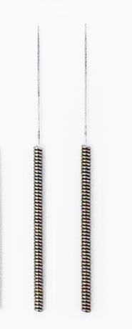  Suitable for Fibroblast Plasma Pen  Acupuncture-style thin needles for Plamere Plasma Pen | $22.50 pack of 5 thin needles  $45.00 pack of 10 thin needles | No wholesale pricing
NON-PLAMERE PLASMA PEN THIN ACUPUNTURE-STYLE NEEDLES  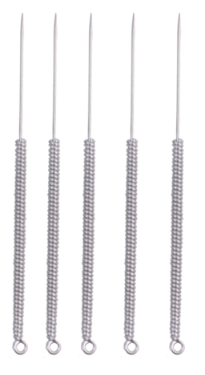  Suitable for Fibroblast Plasma Pen  Acupuncture-style thin needles for Plasma Pen that are not Plamere | $20.00 pack of 5 thin needles | $15.00 for pack of 5 thin needles
REPAIR BALM  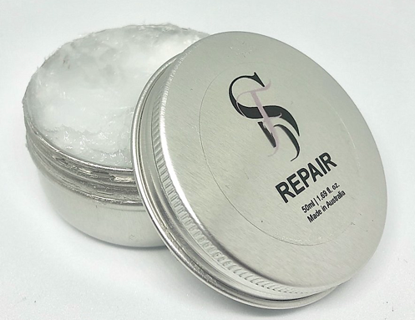  Suitable for all dry and rough skin  Rejuvenates dry skin and creates a sealing barrier on the surface of skin locking in moisture and protecting natural recovery process. | $30.00 per unit (50ml) | $25.00 per unit
GENTLE CLEANSER  Suitable for all treatments  Fragrance-free gentle cleanser. To be used for Dermaplaning and other facials treatments. | $25.00 per unit (100ml) | $20.00 per unit
ROSE WATER TONER  Suitable for all treatments  Rose water toner. To be used for Dermaplaning and other facials treatments. | $25.00 per unit (100ml) | $20.00 per unit
DERMAPLANE STAINLESS STEEL BLADES  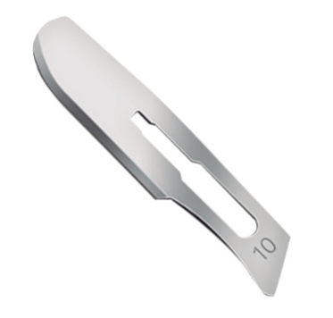  Suitable for Dermaplane  Disposable blades | $30.00 per pack of 10 blades | $25.00 per unit
DERMAPLANE STAINLESS STEEL HANDLE  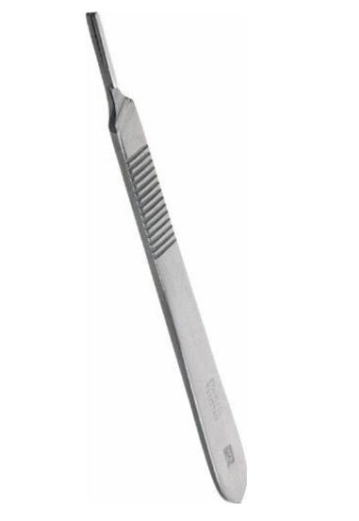  Suitable for Dermaplane  Stainless stell handle for blades | $20.00 per handle | $15.00 per unit
GLISTERINE GEL  Suitable for Fat Cavitation/Body Contouring/RF | Enquire Within | Enquire Within

