FIBROBLAST SKIN AND BEAUTY WHOLESALE PRICE LIST

PRODUCT | RETAIL PRICE | WHOLESALE PRICE  (APPLIES WHEN PURCHASING MORE THAN 1 UNIT)
CLEANSE BOTTLE  (100 ML)  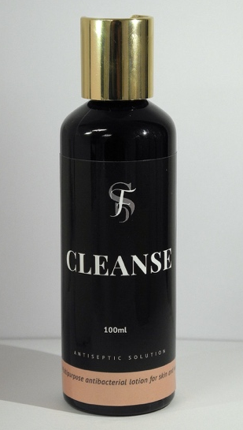  Suitable for all skin treatments on clients and for equipment.  Cleanse is a cleaning agent. To be used to sterilise equipment, device or to clean the client’s skin.  Product Benefits:  - Clinically proven to clean the surface of the skin.  - Cleans and sterilises equipment.  ----------------------------------------------------------  How to use for skin treatments:  This product is to be used prior to skin treatments to remove makeup, numbing cream and other bacteria. Cleanse is important to use with Fibroblast Plasma Pen and Skin Needling treatments prior to commencing the actual treatment. | $30.00 per unit (100ml) | $25.00 per unit
HEAL BOTTLE  (50 ML)  Intense skin healing gel  Suitable for all skin treatments and skin types.  HEAL is a transparent soothing gel infused with Silver Colloidal and Aloe Vera. HEAL leaves a protective coating that acts as a barrier against infection. It helps to deliver rapid tissue healing, anti-inflammatory properties, sun protection, improved skin metabolism, increased moisture retention, a powerful antioxidant and natural moisturiser.  ----------------------------------------------------------  How to use for Fibroblast Plasma Pen:  This product is to be used during the Fibroblast Plasma Pen treatment. It is to be used immediately on the client. HEAL is an essential at-home Fibroblast Plasma Pen aftercare product. It is to be used in combination with our PROTECT product for the first 7 days or while the dots are on.  How to use for facial treatments:  Can be used as a facial healing gel for any skin treatments | $30.00 per unit (50 ml) | $25.00 per unit
PROTECT BOTTLE  (50 ML)  Suitable for all skin treatments.  An antimicrobial pH balancing wound cleaner and fast healing agent.  Product Benefits:  - Clinically proven to promote healing of cuts, burns, scrapes and wounds.  - Safe and non-irritating antimicrobial wound cleanser.  - Allows fast, thorough and gentle cleansing of wounds in all stages  - pH Balancing: helps to maintain wound pH in a desirable range for successful healing  - Facilitates removal of debris, excess exudate and necrotic tissue fragments  ----------------------------------------------------------  How to use for Fibroblast Plasma Pen:  This product is to be used during the Fibroblast Plasma Pen treatment. It is to be used immediately on the client. It can also be sold to clients to use as an at-home aftercare to use in combination with our HEAL product for the first 7 days or while the dots are on.  How to use for facial treatments:  This product can be used two times daily on the face as a cleanser. Suitable for treatments with downtime or no downtime. | $30.00 per unit (50 ml) | $25.00 per unit
RECOVERY SACHETS  (5 GRAMS)  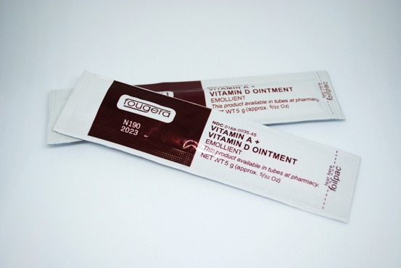  Healing and recovery ointment.  Suitable for all Fibroblast Plasma Pen, Microblading.. For any treatment that creates micro-wounds, cuts or burns. | $15.00 per pack of 5 sachets (5g each) | $10.00 per pack of 5 sachets
100% HYALURONIC ACID SERUM BOTTLE  (100 ML)  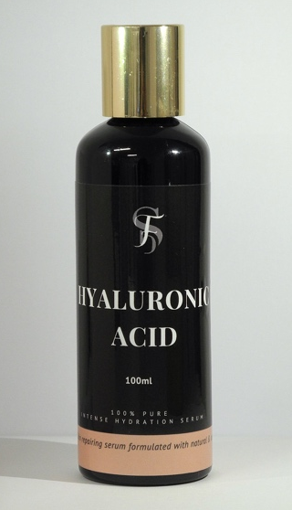  Suitable for all treatments  Multi-purpose and beneficial serum  Product Benefits:  - Smooths fine lines and wrinkles  - Hydrates  - Repairs the barrier of our skin  - Plumps and softens skin  - Increases elasticity  - Heals damaged tissue  - Protects from UV rays  - Antioxidant Defense  - Water retention properties  - Anti-inflammatory properties  ----------------------------------------------------------  How to use for Fibroblast Plasma Pen (post-7 days aftercare):  This product is to be used after the first 7 days post-treatment or after the dots have fallen off. Can also be combined with a moisturiser for intense hydration.  How to use for Skin Needling:  This product is to be used to infuse the hyaluronic acid serum into the skin during the skin needling treatment. | $50.00 per unit (100ml) | $45.00 per unit
BUNDLE PACK  (1x Cleanse Bottle, 1X Heal Bottle & 1X Protect Bottle)  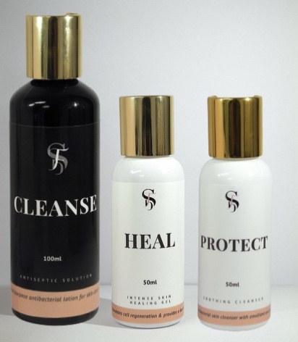  Suitable for all treatments  Refer to each product on the list | $80.00 per bundle pack | $75.00 per bundle pack
PLAMERE PLASMA PEN THIN ACUPUNTURE-STYLE NEEDLES  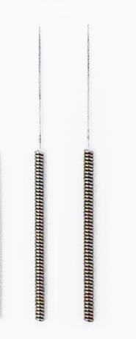  Suitable for Fibroblast Plasma Pen  Acupuncture-style thin needles for Plamere Plasma Pen | $45.00 pack of 10 thin needles | No wholesale on item
NON-PLAMERE PLASMA PEN THIN ACUPUNTURE-STYLE NEEDLES  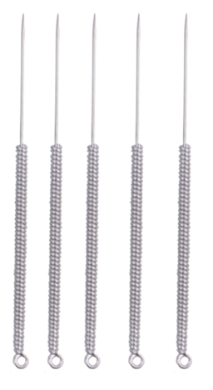  Suitable for Fibroblast Plasma Pen  Acupuncture-style thin needles for Plasma Pen that are not Plamere | $20.00 pack of 10 thin needles | $15.00 for pack of 10 thin needles
GENTLE CLEANSER  (100 ML)  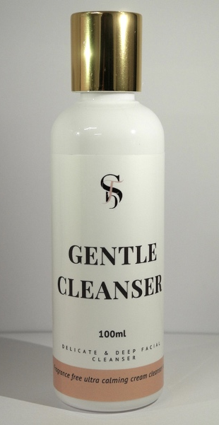  Suitable for all skin treatments  Fragrance-free gentle cleanser  To be used for Dermaplaning and other facials treatments.  ----------------------------------------------------------  How to use for Dermaplane treatment:  This product is to be used to cleanse the skin. It is to be used before using our Rose Water Toner and prior to Dermaplaning. | $25.00 per unit (100ml) | $20.00 per unit
ROSE WATER TONER  (100 ML)  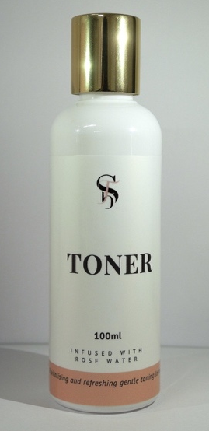  Suitable for all skin treatments  Rose water toner  To be used for Dermaplaning and other facials treatments.  ----------------------------------------------------------  How to use for Dermaplane treatment:  This product is to be used to prep the skin. It is to be used after using our Gentle Cleanser product and is used to tone and prepare the skin prior to Dermaplaning. | $25.00 per unit (100ml) | $20.00 per unit
DERMAPLANE STAINLESS STEEL BLADES  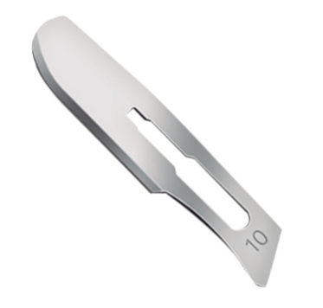  Suitable for Dermaplane  Disposable blades | $30.00 per pack of 10 blades | $25.00 per pack of 10 blades
DERMAPLANE STAINLESS STEEL HANDLE  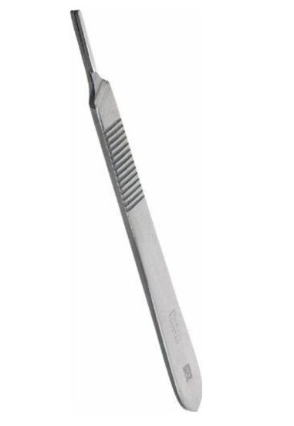  Suitable for Dermaplane  Stainless steel handle for blades | $20.00 per unit | $15.00 per unit
ULTRASOUND CONDUCTIVE GEL  Suitable for Ultrasound Fat Cavitation/Body Contouring/Radio Frequency (RF)  Gel Options:  - 1 Litre  - 5 Litres | $35.00 for 1 litre  $100 for 5 litres | $30.00 per 1 litre unit  $95.00 per 5 litres
PLAXPOT REGENERATION CREAM  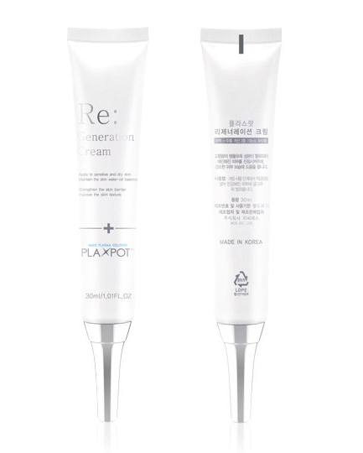  Product Benefits:  - Help the synthesis of collagen in the early stage of wound and promote healing  - Rapidly reduce wound area during wound healing  - Moisturising and calming effect excellent for moisturising, wounds and inflammation of dry skin, controlling sebum & water balance  - Anti-inflammatory, Antioxidant function. Effective in acne treatment and anti-aging. Good for skin soothing  - Improve Elasticity. Helps relieve the movement of skin muscles that cause wrinkles and boost skin elasticity  - Stable, effective, non-irritating for skin conditions and effective for sensitive skin such as soaps, cleansers, lotions, gels and cream | $69.99 per unit | $64.99 per unit
M8 SKIN NEEDLING DEVICE PIN CARTRIDGE  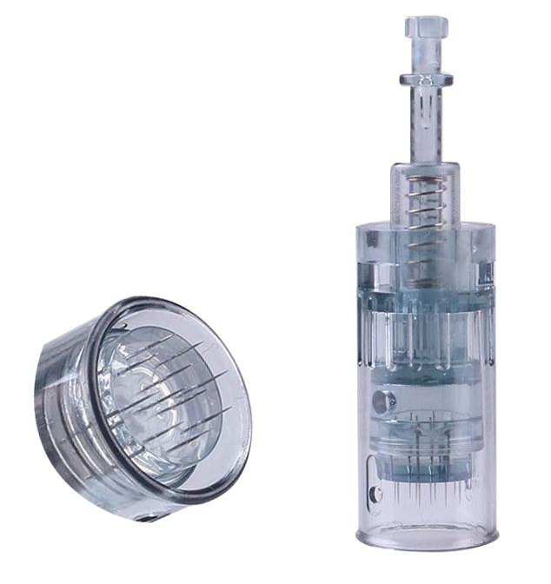  10 pack of Dr. Pen cartridges compatible with the M8 PowerDerm  - The needles are made of high quality stainless steel  - The 11 pin suits anti-aging, hair-loss and skin texture applications best  - The 16 pin suits smaller areas better and is unique to the M8  - The 36 pin suits deep wrinkle, surgical and acne scarring applications best  - The nano pin suits scar treatment, pore or swelling reduction and serum infusion applications best. No cutting or bleeding of the skin.  Pin Options:  - 11 pin  - 16 pin  - 36 pin  - Nano pin | $65.00 per pack of 10 pin cartridges | $60.00 per pack of 10 pin cartridges
M8 SKIN NEEDLING DEVICE PIN CARTRIDGE ASSORTED PACK  10 assorted pack of Dr. Pen cartridges compatible with the M8 PowerDerm  Includes:  2x 36 Pin  3x 11 Pin  3x 16 Pin  2x Nano  Refer to each cartridge description above | $70.00 per pack of 10 pin cartridges | $65.00 per pack of 10 pin cartridges
HYDRA PRO BB GLOW DEVICE PIN CARTRIDGE  10 pack of 12 or Nano needle Dr. Pen cartridges compatible with the Hydra Pro with Serum Capsule  - The needles are made of high quality stainless steel with a plastic compartment for serum dispensing  - The 12 pin suits anti-aging, hair-loss and fine line reduction applications best.  - The nano pin suits scar treatment, pore or swelling reduction and serum infusion applications best. No cutting or bleeding of the skin.  Pin Options:  - 12 pin  - Nano pin | $65.00 per pack of 10 pin cartridges | $60.00 per pack of 10 pin cartridges
BROW LAMINATION KIT  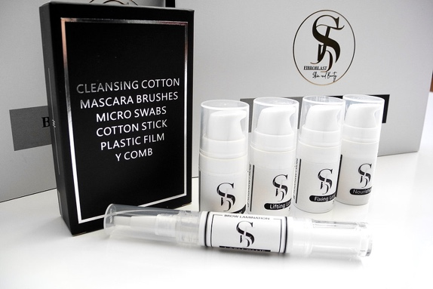  - 1x Cleanser (5ml)  - 1x Lifting Lotion (5ml)  - 1x Fixing Solution (5ml)  - 1x Nourishing Oil (5ml)  - 1x Glue (5ml)  - 6x Cleansing Cottons  - 2x Mascara Wand  - 10x Micro Swabs  - 6x Cotton Sticks  - 2x Y Comb  - 1x Plastic Wrap  Products are vegan and cruelty-free  (Kit Includes Product for up to 15-20 x Treatments.) | $150.00 per kit unit | $145.00 per kit unit
TEETH WHITENING SYRINGE GEL 6% HYDROGEN PEROXIDE (HP)  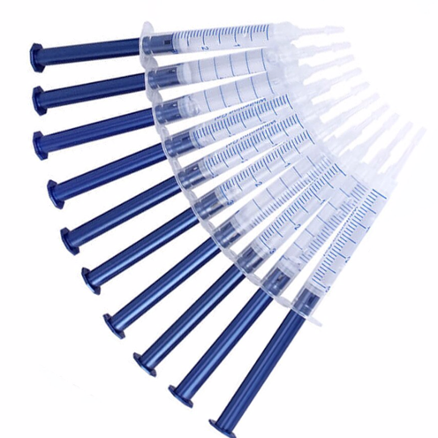  Suitable for Cosmetic Teeth Whitening  1x Syringe Gel 6% Hydrogen Peroxide  3mL | $6.95 per unit | No wholesale on item
TEETH WHITENING ORAL BRUSH UP  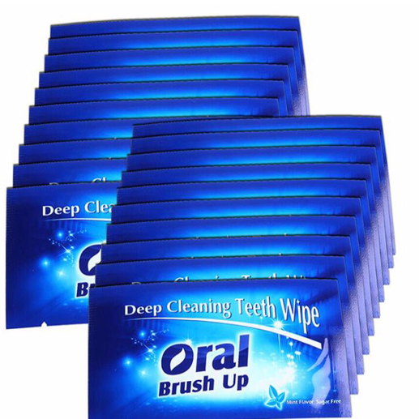  Suitable for Cosmetic Teeth Whitening  1x Oral Brush Up | $0.40 per unit | No wholesale on item
TEETH WHITENING VITAMIN E SWAB  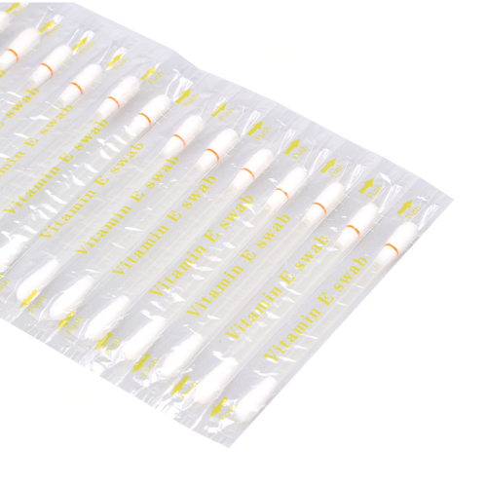  Suitable for Cosmetic Teeth Whitening  1x Vitamin E Swab | $0.30 per unit | No wholesale on item
TEETH WHITENING DESENSITISING SYRINGE GEL  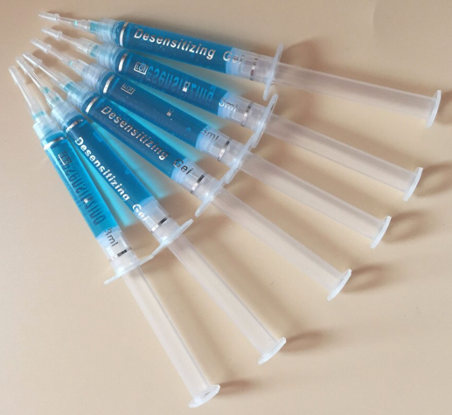  Suitable for Cosmetic Teeth Whitening  1x Desensitising Syringe Gel  3mL  - Teeth whitening desensitisation gel strengthens and revitalizes your teeth by increasing the calcium content. Very important for strength.  - When you use the Remineralisation Gel, Calcium Phosphate, (which is the primary mineral in your teeth and bones) disperses into your teeth to fill the microscopic holes on surface of tooth, making teeth stronger and more resistant to tooth decay. So not only will your smile be radiant, it’ll be long lasting too!  - Remineralization Gel increases the hardness of your tooth enamel and assists in decreasing tooth sensitivity. No more pain!  - Great for people who experience sensitivity to hot and cold. | $6.95 per unit | No wholesale on item
TEETH WHITENING GINGIVAL BARRIER SYRINGE  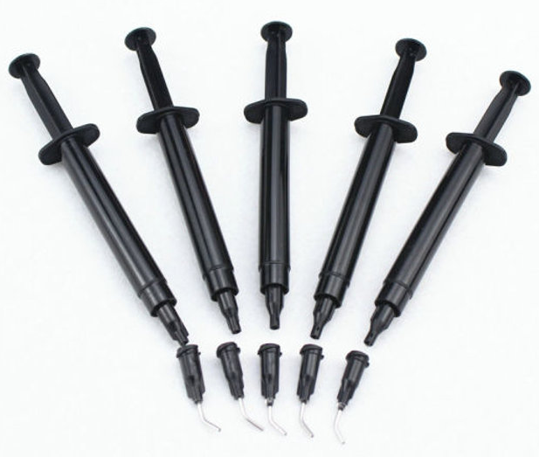  Suitable for Cosmetic Teeth Whitening  1x Gingival Barrier Syringe  3mL  - For gum protection while teeth whitening application.  - Heal gums quickly and evenly with the gingival barrier to protect your patient's gums.  - Includes metal tip for precise application. | $6.95 per unit | No wholesale on item
PLAMERE PREMIUM PLASMA PEN DEVICE  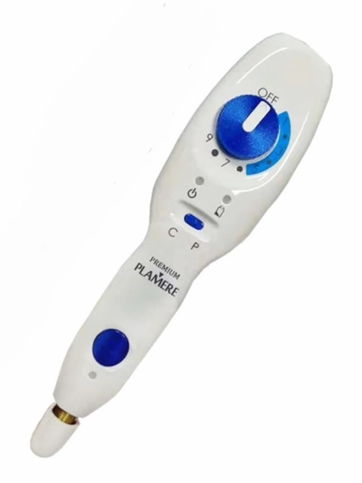  The latest Plamere Plasma Pen: Premium Plamere  - Detachable Battery  - 100% Authentic devices from GCS manufacturer of Plamere (Can provide GCS authorisation letter to verify)  - Full 1 year manufacturer warranty included with your purchase  - TGA and FDA approved device | $2750 per unit | No Wholesale on Item
PLAMERE PREMIUM PLASMA PEN DEVICE SPARE RECHARGEABLE BATTERY PACK  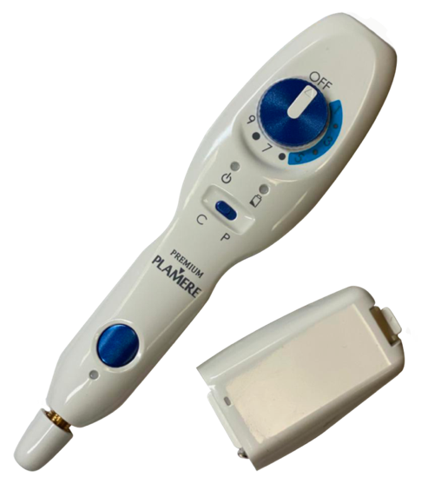  1x Rechargeable Battery Pack  - Detachable Battery  - 100% Authentic devices from GCS manufacturer of Plamere (Can provide GCS authorisation letter to verify)  - Full 1 year manufacturer warranty included with your purchase  - TGA and FDA approved device | $500 per unit | No Wholesale on Item
DR PEN HYDRA PRO DEVICE  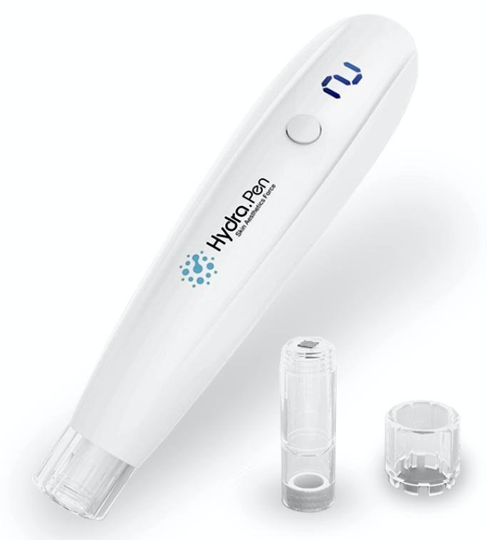  The Hydra Pen is a device for fractional mesotherapy treatment which rejuvenates and brightens the skin. It also combines the functions of microdermabrasion and mesotherapy. | $300 per unit | No Wholesale on Item
DR PEN M8 SKIN NEEDLING DEVICE  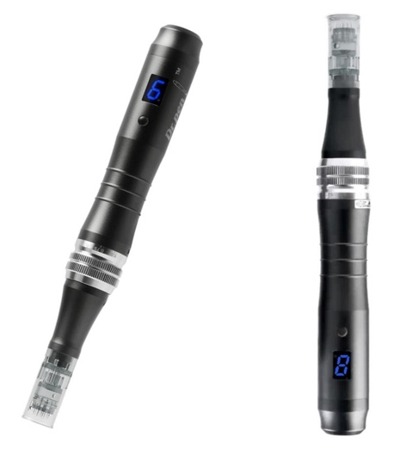  Suitable for Skin Needling  Come with 10 pack cartridge needles (11, 16, 36 or Nano) | $300 per unit | No Wholesale on Item
LED LIGHT THERAPY DEVICE  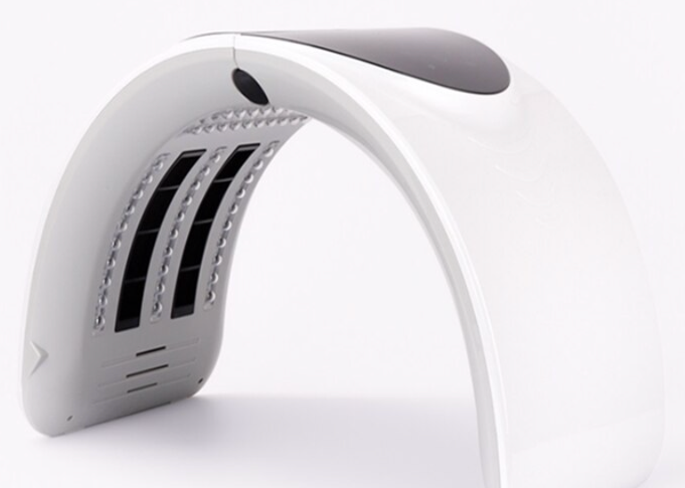  Suitable for all treatments  Benefits of LED Light Therapy:  - Removes skin bacteria  - Reduces pigmentation and blemishes  - Accelerated detoxification of skin metabolism  - Promote skin toxin discharge  - Shrinks pores  - Tightens and rejuvenates  - Brightens skin  - Helps uneven complexion  - Add nutrition and promotes the blood flowing  - Promote skin collagen and elastin  - Reduces inflammation | $390 per unit | No Wholesale on Item

